***VIT BHOPAL UNIVERSITY***

***Patient Symptom Triage System :-***

# *Name :- Vansh Ahuja*

***Registration No. :- 25BHI10003***

***Course :- B.Tech CSE ( Health Informatics )***

***Department :- SCAI***

***Subject :- Problem Solving And Programming***

***Faculty’s Name :- Dr. Sasmita Padhy***

*Full Project Report Submission :-*

***Patient Symptom Triage System :-***

***Vansh Ahuja***

***25BHI10003***

***VIT BHOPAL***

***INTRODUCTION :-***

***This project focuses on developing a console-based patient symptom triage system. It is designed using only basic Python concepts like functions, loops, lists, dictionaries, and conditional statements. The objective is to simulate a real-life symptom evaluation system for learning health informatics decision logic.***

***Problem Statement :-***

***Many patients do not understand the urgency of their symptoms. This project provides a simple system that asks patient symptoms and basic vital signs, and classifies them into Mild, Moderate, or Urgent categories.***

***Functional Requirements :-***

***• Input patient data***

***• Analyze symptoms with rule-based logic***

***• Classify patient condition***

***• Display affected system and department***

***• Provide health advice***

***Non Functional Requirements :-***

***• Easy to use***

***• Fast execution***

***• No external libraries***

***• Runs on basic Python***

***System Architecture :-***

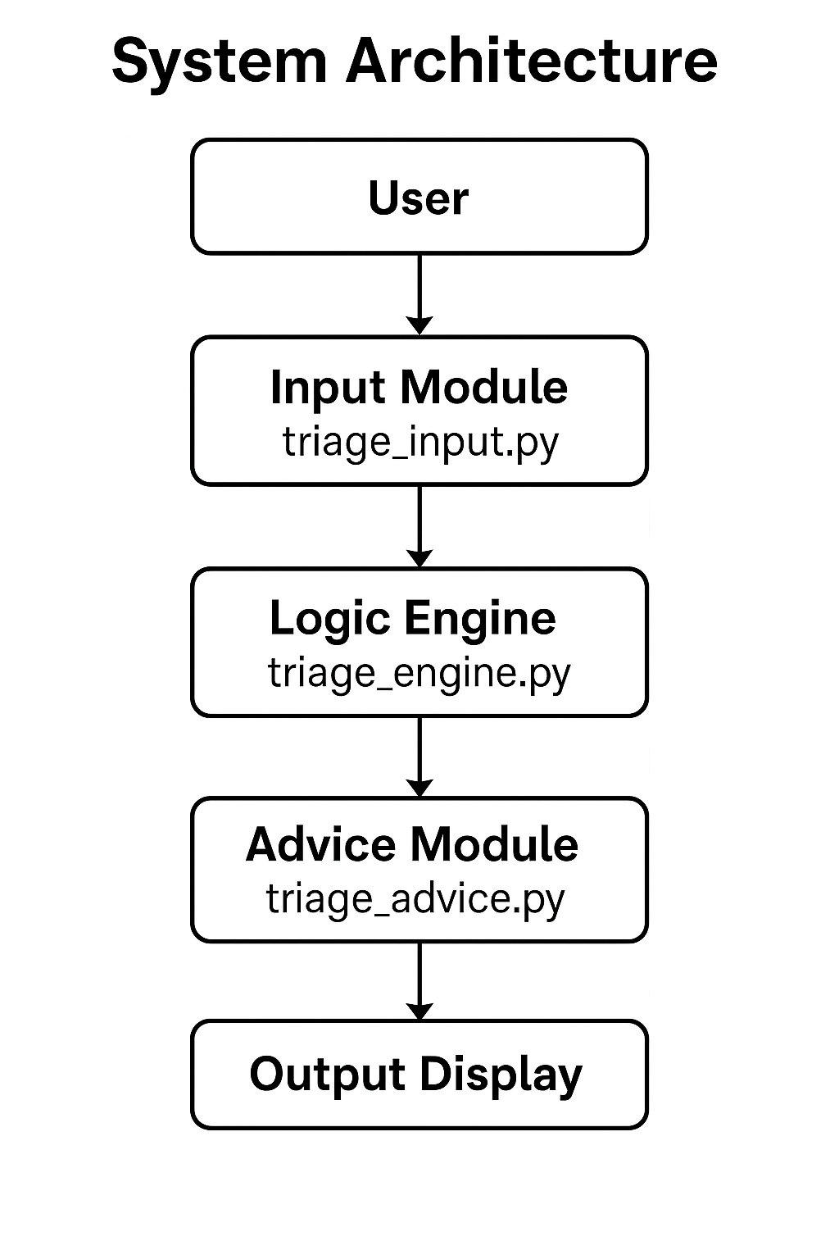

***Design Diagrams :-***

***Use Case Diagram :-***

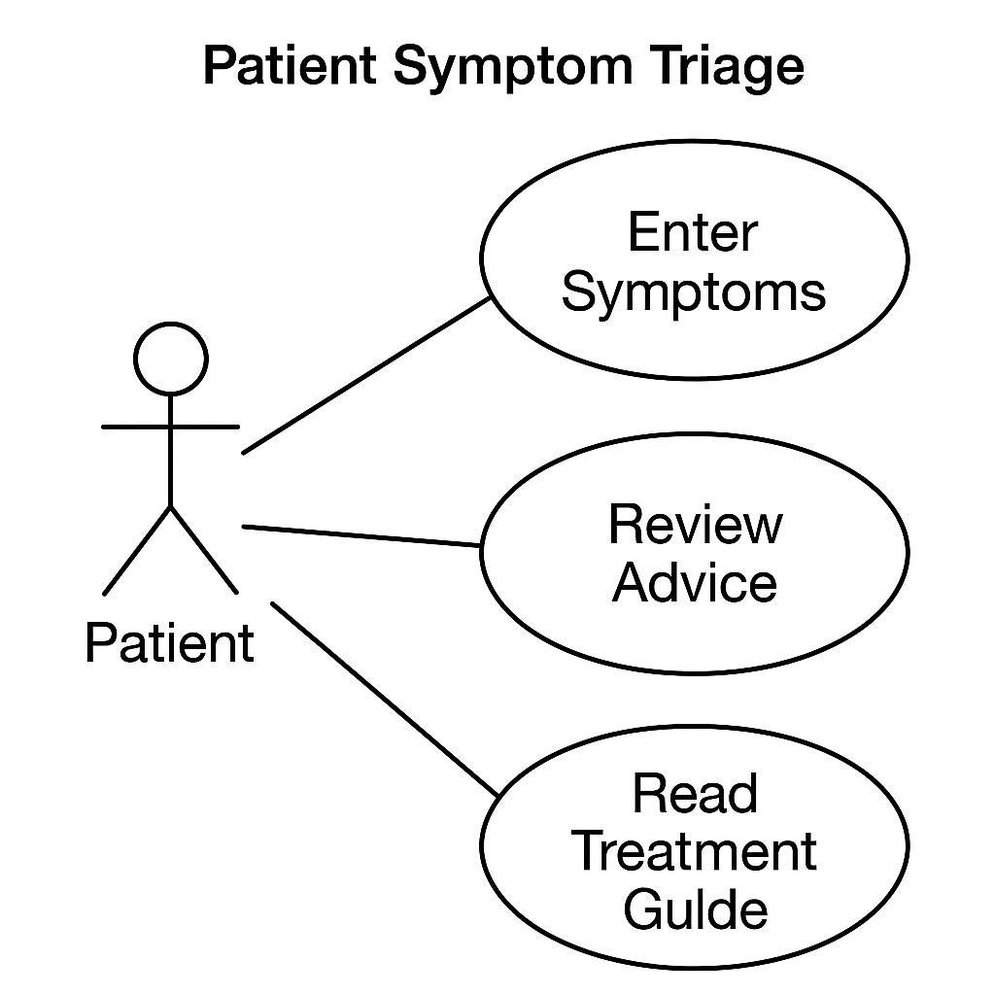

***Workflow Diagram :-***

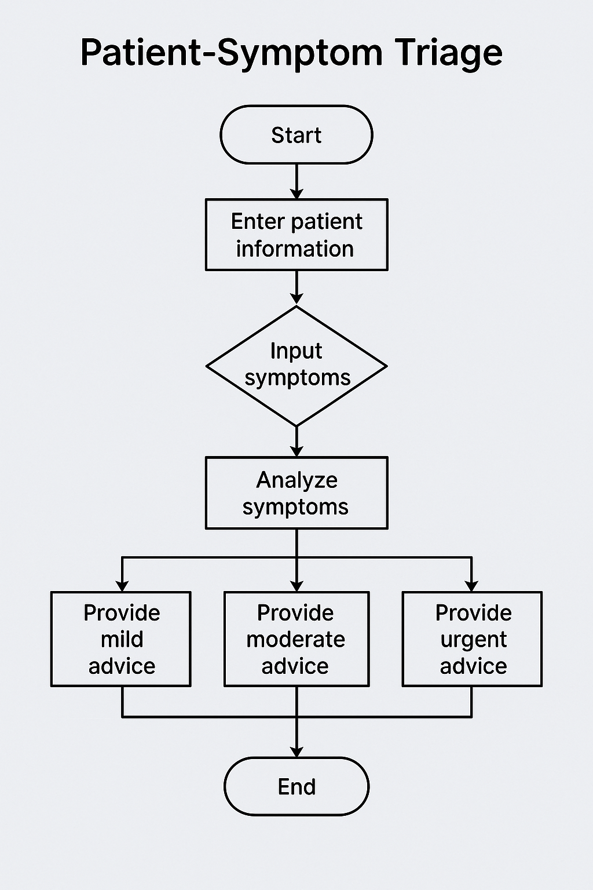

***Sequence Diagram :-***

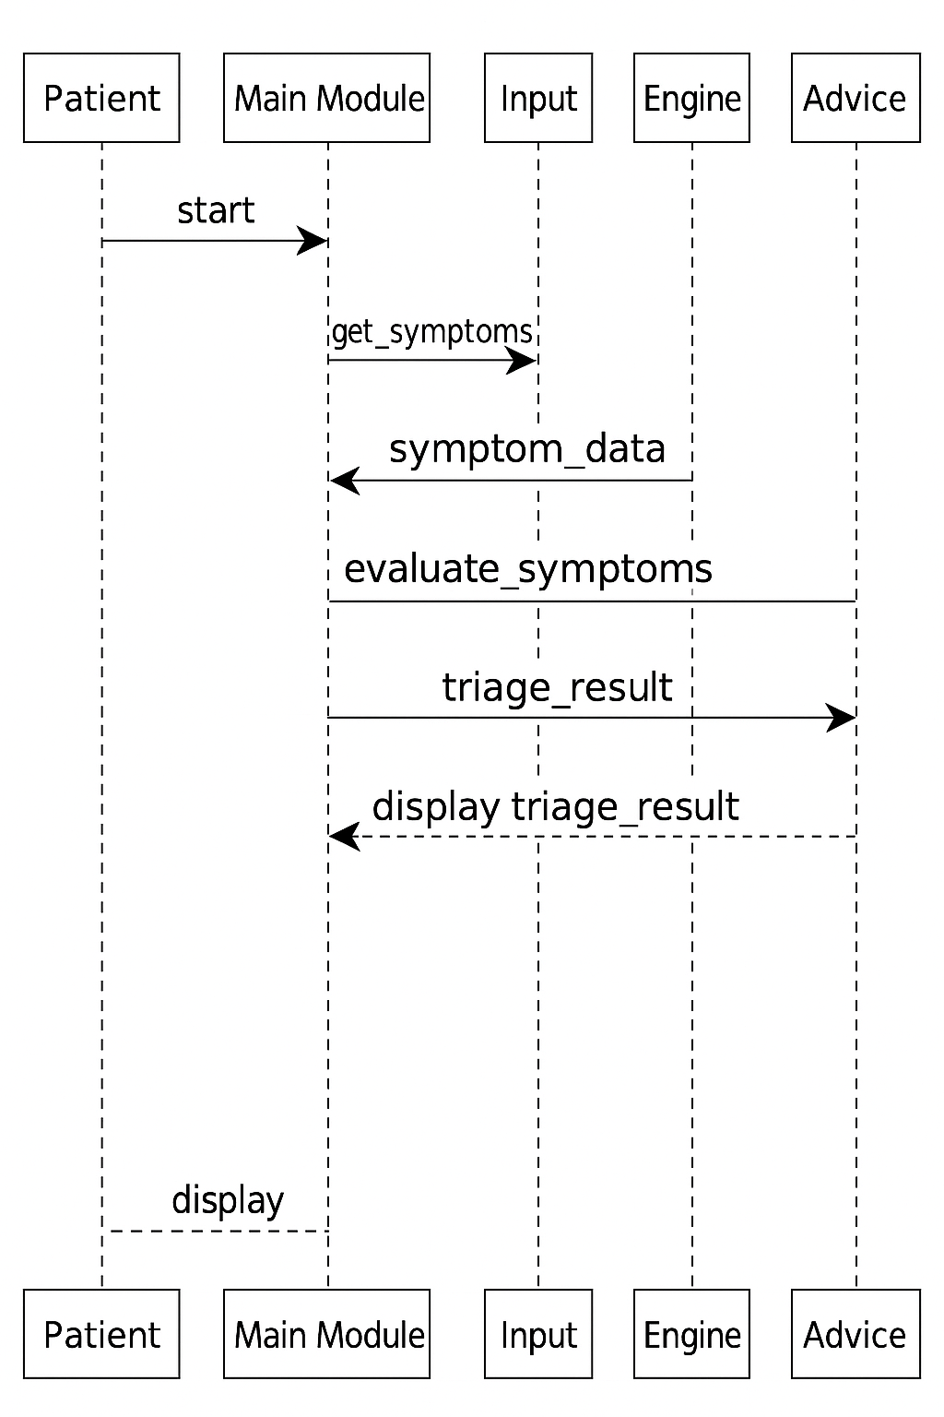

***Class/Component Diagram :-***

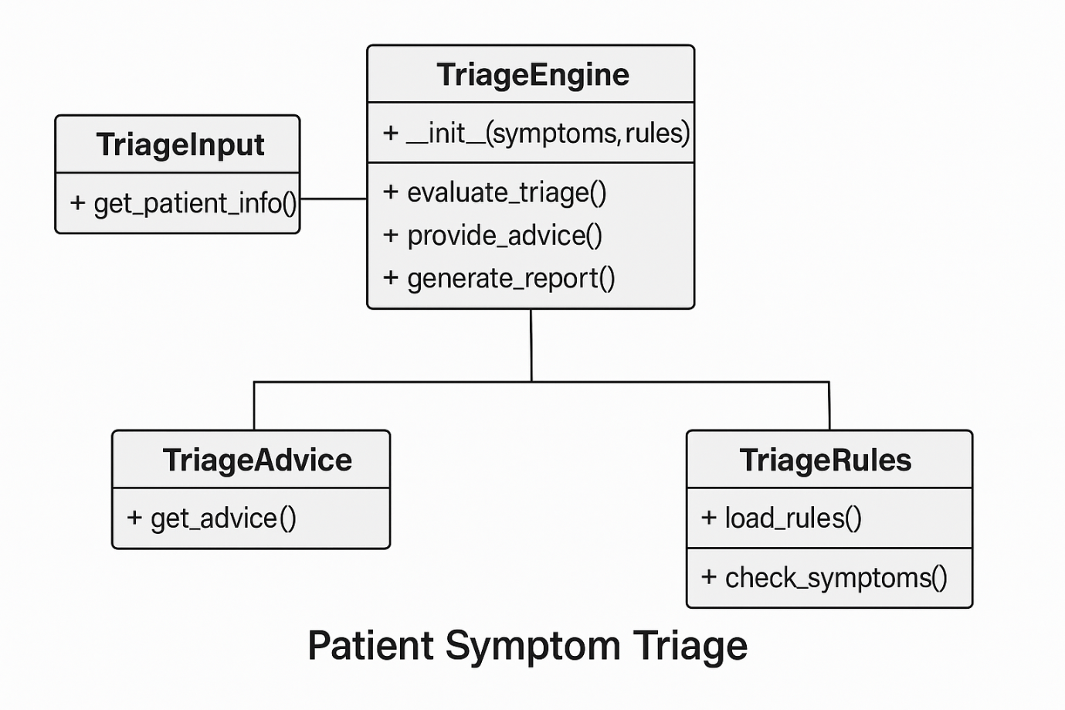

***Design Decisions & Rationale :-***

***We chose rule-based logic because machine learning or AI is not part of the syllabus.  
Using simple conditional statements allows easy understanding and testing***.

***Implementation Details :-***

***The program is written using Python and divided into multiple modules for better  
readability. Each module performs a dedicated function like input, logic processing,or advice generation.***

***Results (OUTPUT) :-***

=== Patient Symptom Triage System ===

1. New Triage

2. View Simple Statistics

3. Exit

Enter your choice (1-3): 1

Enter patient details:

Name: Vansh Ahuja

Age: 19

Enter symptoms separated by comma (,):

Symptoms: diarrhea, stomach pain, nausea, vomiting

Duration of symptoms (in days): 2

Enter vital signs:

BP Systolic: 120

BP Diastolic: 80

Oxygen Saturation (%): 96

Triage Result: MILD - Self-care and observation may be enough.

Category: MILD

Main System: gastrointestinal

Recommended Department: Gastroenterology

Risk Score: 0

Reason: Low risk score and no strong danger signs.

Advice:

- Take rest and drink enough water.

- Watch your symptoms for any change.

- Seek help if symptoms become worse or last too long.

=== Patient Symptom Triage System ===

1. New Triage

2. View Simple Statistics

3. Exit

Enter your choice (1-3): 1

Enter patient details:

Name: Ansh Ahuja

Age: 11

Enter symptoms separated by comma (,):

Symptoms: chest pain, heavy chest

Duration of symptoms (in days): 4

Enter vital signs:

BP Systolic: 185

BP Diastolic: 120

Oxygen Saturation (%): 85

Triage Result: URGENT - Possible cardiac emergency.

Category: URGENT

Main System: cardiac

Recommended Department: Cardiology

Risk Score: 13

Reason: Heart related symptoms with high risk score.

Advice:

- Do not ignore chest pain or pressure.

- Avoid physical activity.

- Seek emergency medical help immediately.

=== Patient Symptom Triage System ===

1. New Triage

2. View Simple Statistics

3. Exit

Enter your choice (1-3): 1

Enter patient details:

Name: Shivam Singh

Age: 20

Enter symptoms separated by comma (,):

Symptoms: shortness of breath, cough

Duration of symptoms (in days): 3

Enter vital signs:

BP Systolic: 160

BP Diastolic: 90

Oxygen Saturation (%): 92

Triage Result: MODERATE - Likely infection. Doctor visit suggested.

Category: MODERATE

Main System: respiratory

Recommended Department: Pulmonology

Risk Score: 7

Reason: Symptoms suggest infection that needs review.

Advice:

- Monitor your symptoms.

- Take rest and maintain hydration.

- Plan a doctor visit if there is no improvement.

=== Patient Symptom Triage System ===

1. New Triage

2. View Simple Statistics

3. Exit

Enter your choice (1-3): 1

Enter patient details:

Name: Ashish Ranjan

Age: 20

Enter symptoms separated by comma (,):

Symptoms: fever, chills, fatigue

Duration of symptoms (in days): 5

Enter vital signs:

BP Systolic: 170

BP Diastolic: 110

Oxygen Saturation (%): 94

Triage Result: MODERATE - Likely infection. Doctor visit suggested.

Category: MODERATE

Main System: general

Recommended Department: General Medicine

Risk Score: 5

Reason: Symptoms suggest infection that needs review.

Advice:

- Monitor your symptoms.

- Take rest and maintain hydration.

- Plan a doctor visit if there is no improvement.

=== Patient Symptom Triage System ===

1. New Triage

2. View Simple Statistics

3. Exit

Enter your choice (1-3): 1

Enter patient details:

Name: Kartikeya Shukla

Age: 21

Enter symptoms separated by comma (,):

Symptoms: loss of consciousness, seizure, difficulty speaking, confusion

Duration of symptoms (in days): 1

Enter vital signs:

BP Systolic: 190

BP Diastolic: 130

Oxygen Saturation (%): 80

Triage Result: URGENT - Possible brain or nerve emergency.

Category: URGENT

Main System: neurological

Recommended Department: Neurology

Risk Score: 20

Reason: Neurological signs with high risk.

Advice:

- Do not drive yourself.

- Stay with someone who can observe you.

- Seek urgent medical care.

=== Patient Symptom Triage System ===

1. New Triage

2. View Simple Statistics

3. Exit

Enter your choice (1-3): 2

=== Simple Statistics (current session) ===

Total patients triaged: 5

URGENT cases: 2

MODERATE cases: 2

MILD cases: 1

=== Patient Symptom Triage System ===

1. New Triage

2. View Simple Statistics

3. Exit

Enter your choice (1-3): 3

Exiting program.

***Testing Approach :-***

***The program was tested using different patient data to verify if classification works  
correctly for urgent, moderate and mild cases.***

***Challenges Faced :-***

1. ***Designing correct symptom rules.***
2. ***Handling different user inputs.***
3. ***Making logic understandable.***

***Learnings & Key Takeaways :-***

* ***Learned modular programming***
* ***Understood rule-based classification***
* ***Improved Python logic skill***

***Future Enhancements :-***

* ***Adding graphical interface.***
* ***Adding patient database.***
* ***Adding more symptoms and rules.***

***References :-***

* ***Python Official Documentation (docs.python.org).***
* ***VIT Course-Notes.***
* ***GitHub and version control tutorials.***